2023 Alabama State Nominating Committee
Greetings Sorors!
We are excited for you to join us at the 2023 Alabama State Association Leadership Conference in Auburn, AL as we gather to handle the business of the sorority. Your willingness to serve Awesome Alabama is greatly appreciated and the 2023 Nominating Committee looks forward to featuring our future leaders of the Alabama State Association (ASA). We ask that you read this document in its entirety so that you may submit a completed nomination packet for review. Please include your signed checklist with the date of completion with the candidate packet.

If you missed the deadline or submitted an incomplete packet, you will not be accepted for consideration in the nomination process. If you want to run from the floor, you must have your completed Nomination Packet, (subject to the same rules as outlined within this packet) ready to provide to the Alabama State Nominating Committee with all the required signatures.

Please see the ASA Bylaws for details on the duties of each office and the qualifications to run and remember, to be elected to a position you must be ZOL certified.

Yours in Service,
2023 Alabama State Nominating Committee

2023 STATE NOMINATING COMMITTEE

Barbara Bolling – Chair
Beta Alpha Omega Zeta
Bboiling02@gmail.com

Cherrite Peterson
Nu Zeta Zeta
PetersonCherrite@gmail.com

April Faulk-Mannings
Alpha Rho Zeta
A.FaulkMannings1920@gmail.com

Dr. Grace Johnson
Nu Zeta Zeta
Grace1852@yahoo.com

CANDIDATE NOMINATION PACKET

- Financial on ALL levels (National, Regional, State, and Local)

- ZOL Certified

- Candidate Application - All sections are completed and typewritten

- Zeta Headshot ( png, jpeg or bmp format)

- Zeta Resume’

- All applicable signatures affixed to Verification Form

- Signed and dated Checklist Form

Candidate Nomination packet must be submitted by Friday, September 15, 2023 to alabamasnc@gmail.com

_____________________________________________________________
Print Name

____________________________________________________________________________
Signature Date

Please contact a member of the Nominating Committee should you have any questions or concerns regarding the nomination process or the nomination packet.

CANDIDATE APPLICATION

Name

Address

City/State/Zip Code

Email Address Phone Number________________________

Membership Intake ___________ Year of Induction Chapter_________________

Campus/City, State____________________________________________________ Membership ID Number (Life Members use your LM, DLM, GLM, or PLM#) ________
Please check if you have not received your Membership ID
“PENDING Receipt from Nationals”

Are you a college graduate? Yes No

Registered Conferences:

# of Grand Boules Four Most Recent Years Attended
# of Regional Conferences Two Most Recent Years Attended
# of State Meetings Two Most Recent Years Attended _________________

ZOL Certification (Check One): Yes No (attach copy of certificate or certification letter)
Office Pursuing (Check One)
- Tamias*
- Phylactor*
- Chair of the Nominating Committee
- Member of the Nominating Committee (2)*
*These positions consist of a term of two years

QUALIFYING EXPERIENCE

Summarize your qualifying experiences relevant to the position you seek: State your platform/ or reason for the position you are seeking:

VERIFICATION SIGNATURE FORM

The signature of the candidate and the Chapter Basileus (or First Anti-Basileus if the nominee is the Chapter Basileus*) is required below. For floor nominations, the State Tamias Grammateus’ signature** is acceptable only if the candidate’s Chapter Basileus and First Anti-Basileus are not present at the State Meeting.

__________________________________________________________________________________________
Candidate Name Chapter Basileus Name (or First-Anti Basileus*)

Candidate Signature Chapter Basileus Signature (or First-Anti Basileus*)

____________________________________
Date

Person Verifying Candidate:

Basileus___________________________________________________________
First Anti-Basileus____________________________________________________
State Director (floor nominations only**) __________________________________
Verifier’s Phone Number: ______________________________________________
Verifier’s Email Address: _

* THE CANDIDATE’S CHAPTER BASILEUS MUST VERIFY, OR THE FIRST ANTI-BASILEUS IF THE CANDIDATE HOLDS THE BASILEUS POSITION IN HER CHAPTER.

** FOR FLOOR NOMINATIONS, THE STATE DIRECTOR or THE STATE TAMIAS GRAMMATEUS’ SIGNATURE IS ACCEPTABLE ONLY IF BOTH THE CANDIDATE’S CHAPTER BASILEUS AND FIRST ANTI-BASILEUS ARE NOT PRESENT AT THE STATE MEETING.

Failure to complete all sections of this form and provide all required attachments will result in your application being disqualified. All sorors whose signature appears on this nomination form warrant they have verified the candidate is in good standing and meets the qualifications as outlined in the Zeta Phi Beta Sorority, Incorporated Alabama State Association Bylaws, adopted November 20, 2021 at the 2021 Alabama State Association Meeting in Huntsville, Alabama.

2023 Alabama Association of Zeta Phi Beta Sorority, Inc. - State Nomination Packet

By submitting this form, you grant permission for the information contained in the completed form to be printed in the 2023 Alabama State Association Conference materials.

The Alabama State Nominations Committee may request additional information. All photographs become the property of the Alabama State Association.
DEADLINE: Friday, September 15, 2023

QR CODE:2023 ASA Nomination Package in Google Form
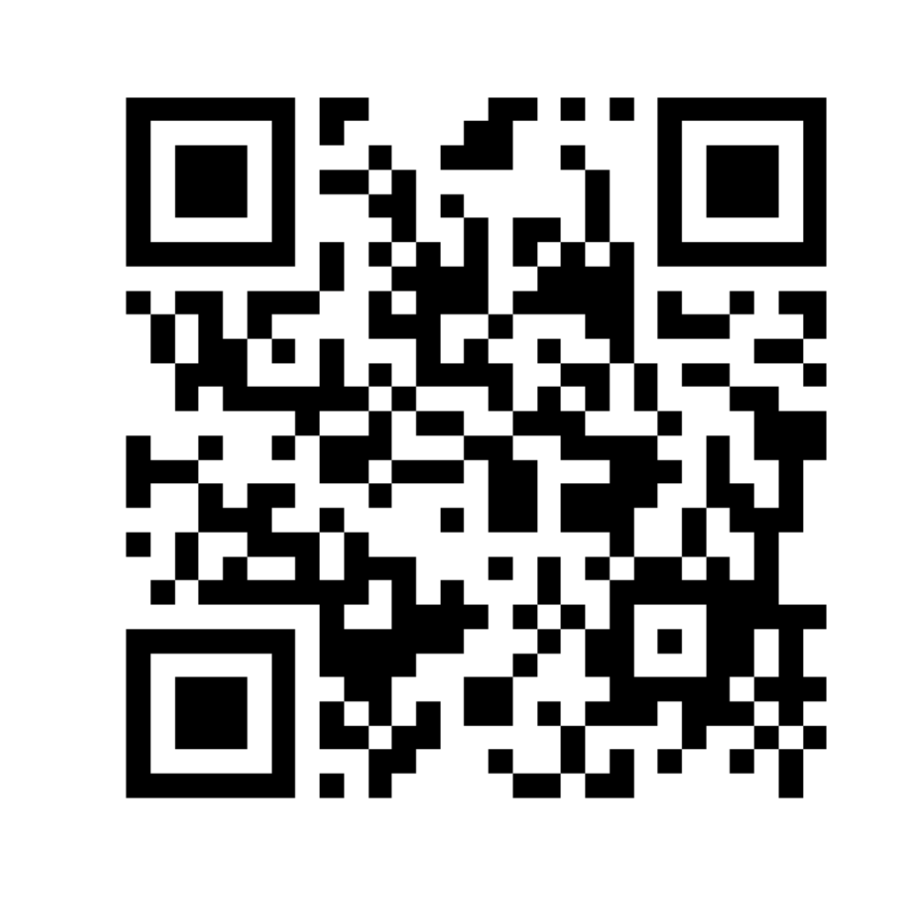

LEFT BLANK INTENTIOANLLY

